RETAIL SALES AND PROFITABILITY
Exploratory Data Analysis using Tableau
Week 1 Task – Exploratory Data Analysis and Insight Generation
Prepared using Tableau Desktop
Dataset: Tableau Sample – Superstore
Analysis period represented in the workbook: 2023–2026
Prepared by: Ashwa Desai

1. Executive Summary
This report documents an exploratory data analysis (EDA) of the Tableau Sample – Superstore retail dataset. The analysis was performed in Tableau using the Orders table and focuses on sales, profit, discount, customer segment, product category, sub-category, region, state and time. The objective was to understand the structure of the data, identify visible trends and outliers, and translate those observations into potential business questions for further investigation.
The Tableau workbook contains a sequence of exploratory worksheets covering data overview, time-period analysis, monthly sales, profit trends, category analysis, category profitability, sub-category performance, discount versus profit, regional analysis, state-level mapping, customer-segment analysis and order-level outliers.
At the overall level, the workbook's Data Overview shows total Sales of approximately 2,326,534 and total Profit of approximately 292,297. The category analysis shows Technology with the highest displayed profit (146,543), followed by Office Supplies (126,023) and Furniture (19,730). The regional analysis shows West with the highest displayed profit (110,799), followed by East (94,883), South (46,749) and Central (39,865).
The discount-versus-profit scatter analysis shows different relationships by category: the fitted trend lines are downward for Furniture and Technology and upward for Office Supplies in the workbook. This is an association visible in the exploratory view; it should not be interpreted as proof that discounting directly causes changes in profit. The order-level outlier view also shows a relatively concentrated cluster of ordinary orders alongside a smaller number of orders with unusually high sales or unusually high positive/negative profit.

2. Dataset Description
The dataset used is Tableau's Sample – Superstore dataset. Tableau describes Superstore as a sample retail dataset containing information about products, customers and sales and notes that it represents a fictitious company. The dataset is publicly available through Tableau's Sample Data resources.
Official Tableau sample-data source: Tableau Public – Sample Data.
Tableau documentation describing Sample – Superstore: Tableau Help – Build a Basic View.
The Tableau workbook supplied for this project connects to an Excel file named sample_-_superstore.xls and uses the Orders table. The workbook metadata identifies the Orders table range as A1:U10195, indicating a header row plus approximately 10,194 order-line records in the connected source represented by the workbook.

3. Business Objective and EDA Questions
- Understand the overall scale of sales and profit in the dataset.
- Examine how sales and profit change over time.
- Compare profitability across product categories and sub-categories.
- Explore regional and state-level differences in sales and profit.
- Compare customer segments using sales and profit.
- Explore the relationship between discount and profit.
- Identify unusually high or low sales/profit observations that may require investigation.
- Generate business questions that could support a deeper analysis in later stages.

4. Data Fields and Variables
Field | Type | Role in EDA | Use in Analysis
Row ID | Integer | Identifier | Row-level reference
Order ID | String | Identifier | Order-level analysis and outlier view
Order Date | Date | Dimension | Monthly and yearly trends
Ship Date | Date | Dimension | Available for time/shipping analysis
Ship Mode | String | Dimension | Potential operational analysis
Customer ID | String | Identifier | Customer-level analysis
Customer Name | String | Dimension | Customer analysis
Segment | String | Dimension | Consumer, Corporate and Home Office comparison
Country/Region | String | Geographic dimension | Geographic analysis
City | String | Geographic dimension | Geographic drill-down
State/Province | String | Geographic dimension | State-level map
Postal Code | Integer | Geographic field | Geographic detail
Region | String | Dimension | Regional comparison
Product ID | String | Identifier | Product analysis
Category | String | Dimension | Category profitability
Sub-Category | String | Dimension | Sub-category performance
Product Name | String | Dimension | Product-level drill-down
Sales | Real | Measure | Sales performance
Quantity | Integer | Measure | Volume analysis
Discount | Real | Measure | Discount analysis
Profit | Real | Measure | Profitability analysis

5. Data Preparation and Tableau Setup
The analysis was performed directly in Tableau. The workbook metadata shows that Tableau recognized the main fields as dates, strings, integers or real-valued measures. No major external data transformation is documented in the workbook. The analysis therefore focuses on Tableau's aggregation, filtering, grouping, geographic mapping, trend visualization and analytical features.
- Connected the Orders table from the Sample – Superstore Excel source.
- Reviewed dimensions and measures in the Tableau Data pane.
- Used SUM(Sales) and SUM(Profit) for aggregate business-performance views.
- Used Order Date at monthly/yearly levels for time-series exploration.
- Used Category, Sub-Category and Segment to compare groups.
- Used Region and State/Province for geographic exploration.
- Used Discount and Profit in a scatter plot with category-level trend lines.
- Used Order ID, Sales and Profit to inspect order-level outliers.

6. Exploratory Analysis Performed
Worksheet | Purpose
01. Data Overview | A high-level view of aggregate Sales and Profit was used to establish the scale of the dataset.
02. Time Period | Year-level temporal structure was explored to understand the available time periods.
03. Monthly Sales Trend | Monthly Sales was plotted over time, with separate yearly series to make changes in the sales pattern easier to inspect.
04. Profit Trend | Monthly Profit was plotted to examine fluctuations and periods of stronger or weaker profitability.
05. Category Analysis | Sales were compared across the three main product categories.
06. Category Profit | Profit was compared across Technology, Office Supplies and Furniture.
07. Sub-category Analysis | Sales were displayed by sub-category and colored by Profit, making high-sales and low/negative-profit areas easier to identify.
08. Discount vs Profit | Average Discount was compared with Profit using a scatter plot, category coloring and fitted trend lines.
09. Regional Analysis | Regional Sales were compared and the marks were colored by Profit to add a second performance dimension.
10. State Profit Map | State-level geographic performance was visualized using a filled map with Profit as the color measure and Sales as an additional measure.
11. Segment Analysis | Customer segments were compared using Sales and Profit.
12. Order Outliers | Order-level Sales and Profit were plotted to identify observations that sit far away from the main cluster.

7. Key Findings and Insights

7.1 Overall Sales and Profit
The Data Overview worksheet displays total Sales of 2,326,534 and total Profit of 292,297. This provides the baseline for interpreting the remaining views. The positive aggregate profit indicates that the dataset is profitable overall, while the category, region and order-level views show that performance is not uniform across all parts of the business.

7.2 Sales Trend Over Time
The Monthly Sales Trend shows substantial month-to-month variation. The later years displayed in the workbook contain several high-sales months, with the 2026 series reaching the highest visible monthly peak, at a little under 120K around November. Earlier years also contain sharp peaks, indicating that sales are not evenly distributed across months.
Potential business question: Are the recurring peaks associated with specific months, product groups, customer segments, promotions or order patterns? A follow-up analysis could compare monthly seasonality across categories and regions.

7.3 Category Profitability
Technology has the highest displayed category profit at 146,543. Office Supplies follows at 126,023, while Furniture is considerably lower at 19,730. The difference suggests that category-level profitability deserves separate attention rather than relying only on total sales.
- Technology contributes the largest displayed amount of profit.
- Office Supplies also contributes a substantial amount of profit.
- Furniture has a much smaller displayed profit contribution and warrants further investigation at sub-category level.

7.4 Sub-category Performance
The sub-category analysis shows considerable variation in profit. Copiers, Phones and Chairs are among the higher-profit sub-categories displayed, while Tables and Bookcases show negative profit in the visual. The chart therefore demonstrates why category-level averages can hide important differences between individual sub-categories.
A useful follow-up would examine whether negative-profit sub-categories are associated with higher discounts, specific regions, customer segments or individual products.

7.5 Regional Performance
The regional analysis displays the following profit values: West 110,799; East 94,883; South 46,749; and Central 39,865. West therefore has the largest displayed profit contribution in the regional view, while Central has the smallest.
The regional chart also displays Sales on the horizontal axis, while Profit is used for the color encoding. This allows the dashboard user to consider both scale and profitability rather than looking at sales alone.

7.6 State-Level Geographic Pattern
The filled state map reveals geographic variation in profit, with states shown using a diverging color scale. The visual contains both positive- and lower/negative-profit areas, indicating that aggregate regional performance can contain meaningful state-level differences. The map is particularly useful for identifying locations that deserve drill-down analysis.

7.7 Customer Segment
The segment analysis shows Consumer as the largest displayed profit contribution at 136,371, followed by Corporate at 94,250 and Home Office at 61,676. The segment view is useful because customer mix can influence both sales volume and profitability.

7.8 Discount Versus Profit
The Average Discount vs Profit scatter plot separates observations by category and includes fitted trend lines. Furniture and Technology show downward-sloping fitted lines in the workbook, while Office Supplies shows an upward-sloping line. The visual therefore indicates that the association between average discount and profit differs by category.
This should be treated as an exploratory association, not a causal conclusion. Discount may interact with product mix, order size, customer type and region. A later analysis could calculate profit margin and compare discount bands within each category and sub-category.

7.9 Order-Level Outliers
The order-level scatter plot shows a dense cluster of observations around relatively small Sales and Profit values, together with a smaller number of observations far from the main cluster. Visible extreme observations include orders with profit above approximately 8K and orders with losses below approximately -6K. There are also orders with sales extending beyond 20K.
These observations are not automatically errors. They are candidates for investigation because they can materially affect aggregate results and may reflect unusual products, discounts, customers, order sizes or other business conditions.

8. Business Insights and Potential Actions for Further Investigation
- Investigate Furniture profitability at sub-category and product level because its displayed category profit is much lower than Technology and Office Supplies.
- Review negative-profit sub-categories such as Tables and Bookcases to identify whether discount, product mix or regional concentration is associated with the losses.
- Investigate high-performing Technology sub-categories and products to understand the sources of the category's strong profit contribution.
- Compare regional performance at state level to determine whether weaker states are concentrated within particular product categories.
- Examine monthly seasonality by category and region to determine what drives the strongest sales months.
- Segment discount analysis by category and sub-category before drawing conclusions about discounting strategy.
- Review extreme order-level observations individually to distinguish genuine business events from data-quality issues.
- Add profit margin (Profit / Sales) in a future iteration so that profitability can be compared independently of sales scale.

9. Tableau Dashboard Design
The final dashboard combines six complementary views into one page. The monthly sales trend provides the temporal overview, while the state map provides geographic context. Category profitability, regional performance, discount versus profit and customer-segment performance provide additional business dimensions. This combination supports exploratory analysis by allowing the reader to move from an overall trend to specific product, geographic and customer dimensions.
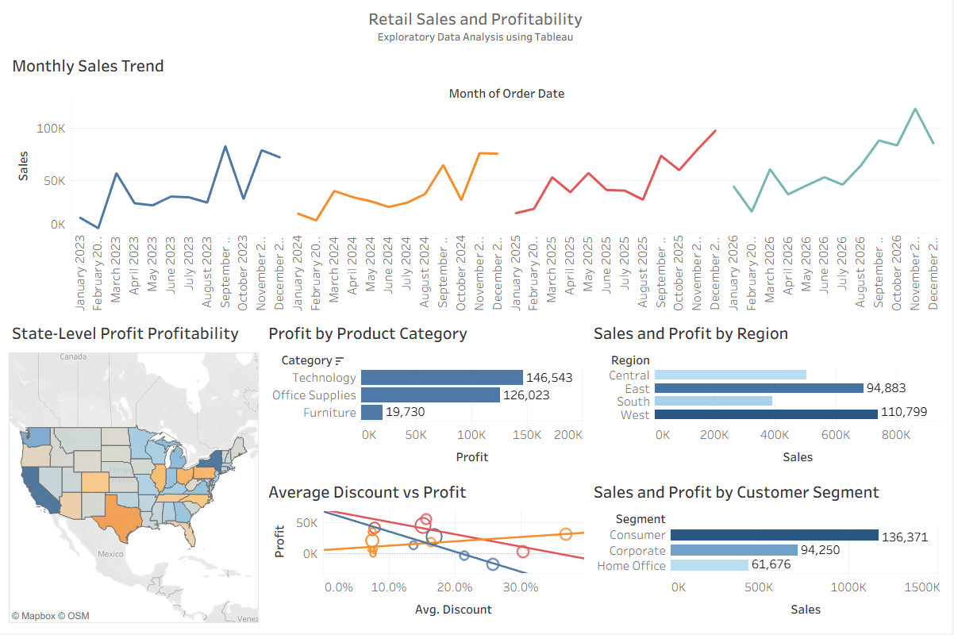
Figure 1. Final Tableau dashboard – Retail Sales and Profitability.

10. Limitations
- The dataset is a fictitious sample dataset rather than live company data, so the findings should not be interpreted as actual market performance.
- The analysis is exploratory and descriptive; it does not establish causality.
- The dashboard uses aggregated measures in several views, so detailed product-level investigation would be required before making operational decisions.
- The discount-versus-profit chart shows category-specific associations, but additional controls would be needed to isolate the effect of discounting.
- Outliers identified visually require record-level review before being treated as errors or exceptional business cases.

11. Further Investigation
The next stage of analysis could extend the EDA into diagnostic and explanatory analysis. Suggested additions include profit margin, sales per order, average order value, year-over-year growth, category-by-region heat maps, discount bands, top and bottom products, and customer-level concentration. Statistical measures such as correlation within homogeneous product groups could also be used to complement the visual trend lines.

12. Conclusion
The Tableau EDA demonstrates that the Superstore dataset contains multiple dimensions that can be used to understand retail sales and profitability. The analysis identifies meaningful variation across time, product categories, sub-categories, regions, states, customer segments and discount levels. The most prominent observations are the strong displayed profitability of Technology, the lower displayed profitability of Furniture, regional differences in profit, category-specific discount/profit patterns, and the presence of order-level outliers.
The dashboard provides a structured starting point for deeper analysis. Rather than treating the exploratory findings as final conclusions, the next stage should test the underlying drivers using more granular product, customer, geographic and temporal comparisons.

13. Submission Details
The project includes the Tableau workbook, EDA report and final dashboard. The complete project files are submitted through the designated GitHub repository.
GitHub repository URL: https://github.com/AshwaDesai/Retail-Sales-Profitability-EDA

14. References
- Tableau Public. Sample Data – Superstore Sales. https://public.tableau.com/app/learn/sample-data
- Tableau Help. Build a Basic View to Explore Your Data. https://help.tableau.com/current/pro/desktop/en-us/getstarted_buildmanual_ex1basic.htm
- Tableau Help. Find Good Data Sets. https://help.tableau.com/current/pro/desktop/en-gb/find_good_datasets.htm

